DIS-POINTS-ALACHUA- Bainbridge, Georgia

SHAPE \* MERGEFORMAT 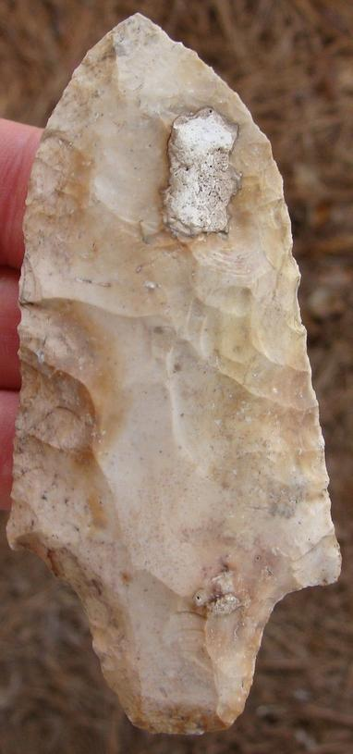 SHAPE \* MERGEFORMAT 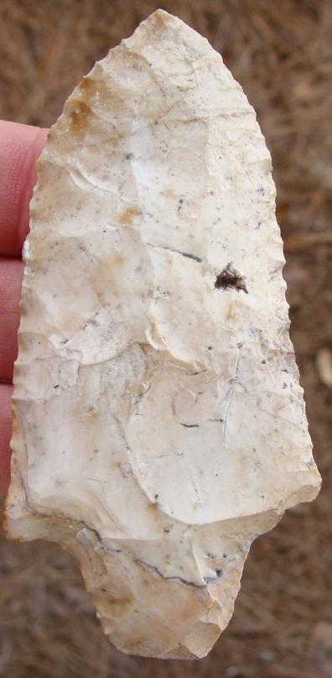

# 

3 3/4" ALACHUA Deep South